Gabon Fang Figure —Mid-20th Century   
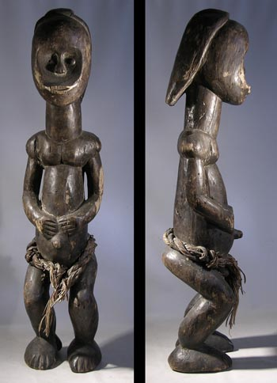  
A nice Fang figure from the Gabon area of Western Africa. He stands on large feet with hands held to the stomach. A woven fiber waist wrap is secured with iron nails. Nails are also used for the eyes. Condition is good. Both legs have been reattached. Minor insect damage, surface scrapes and erosion consistent with age and exposure to the elements. These types of "Bieri" figures are among the most desirable of all African sculptures. A fine example showing signs of tribal use and aged patina.   
  
Approx. 23" tall   
  
$850